**E Pele E Pele**

E Pele e Pele ka`uka`ulï ana

E Pele e Pele hua`ina hua`ina

E Pele e Pele `oni luna `oni luna

E Pele e Pele `oni lalo `oni lalo E Pele e Pele a`o kuli pe`e nui Ha`ina ka inoa no Pele la ea Eala eala ea, a i e a-----

He inoa no Pele

O Pele o Pele, moving along

O Pele o Pele, bursting forth

O Pele o Pele, moving upward

O Pele o Pele, moving downward

O Pele o Pele, creeping, hiding your big knees

In the name of Pele

Tra la la

In the name of Pele

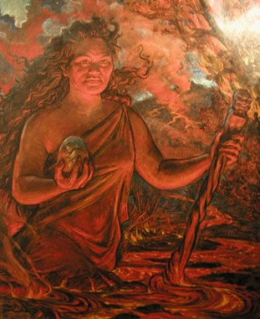

This mele is a HULA PELE(sacred dances for Pele), a name chant which is in honor of the Fire Goddess Pele. Hula Pele are generally very active, bombastic, and grounded dances. The poetic name for Pele is *Ka wahine ‘ai honua*, the woman who devours the earth.